### Developing a self regulating control system for intravenous drug administration -- using aminoglycosides as an example

**Project Members**

|  |  |
| --- | --- |
| **Primary Contact** | **Secondary Contact** |
| Palaniappan Ganesh Nagappan  Physiology Department  Emmanuel College  Cambridge  pgn25@cam.ac.uk | David Chong Tian Wei  Genetics Department  St Edmund’s College  Cambridge  dtwc3@cam.ac.uk |
| Primarily contribute to the design and programming of the pump and help with the development of the sensor. | Primarily contribute to the design and programming of the pump and help with the development of the sensor. |

**Summary**

Our goal is to put together a sensor-pump system which would be able to adjust drug output of aminoglycosides based on real time sensing of drug in plasma. This would involve several stages, the first being the development of a functional sensor over the appropriate therapeutic range of concentrations. Similarly, a device will be designed which can attach to current hospital drip bags to control output and have configurable parameters for information such as normal drug clearance, volume of distribution, concentration of drug being delivered, and so on. The software to calculate the appropriate output will also be written.

**Problem being addressed**

Drugs with a low therapeutic index or coping with patients with altered clearance due to situations such as liver or kidney failure can make the administration of the right amount of a drug difficult. Current monitoring procedures often involve laboratory tests which have an inherent delay as a result of logistic issues. As a result, patients may have plasma drug concentrations that are outside of the therapeutic window temporarily, which may increase the risk of side effects or ineffective treatment.

**Outcomes and Benefits**

It is hoped that developing such automated delivery systems will be able to simplify drug administration and reduce errors. This will be very useful in the future of personalised medicine, where it would be especially appropriate in patients with multiple comorbidities, that do not conform to the rest of the population by which the current system of drug administration is based on. In the process we also hope to develop a cheap and simple way to create an effective microfluidic device, which could also be used for many other purposes.

**Biological Systems to be used**

Electrochemical-aptamer based (E-AB) biosensors have been chosen for the sensor design as there are established designs available, have appropriate sensitivity, specificity, and dynamic range, and allows for easier interfacing with electrical devices. This would then be picked up, analysed and output to the pump by a control device.

**E-AB sensor design**

Electrochemical Aptamer based sensor(E-AB). The design and development of the E-AB sensor will need to be the first phase of the project. Ideally it should be a microfluidic device to enable portability and hopefully reduce cost. We will be researching to design and develop a simple microfluidic sensor chip which will need several components. We will first need to fabricate the sensor through attaching the aptamer to the gold leaf, following an immobilisation protocol1. Then, a platform will be designed for fluid flow, as detailed in diagram below. The gold leaf would be cut into the shape of the electrodes before being layered onto the platform. 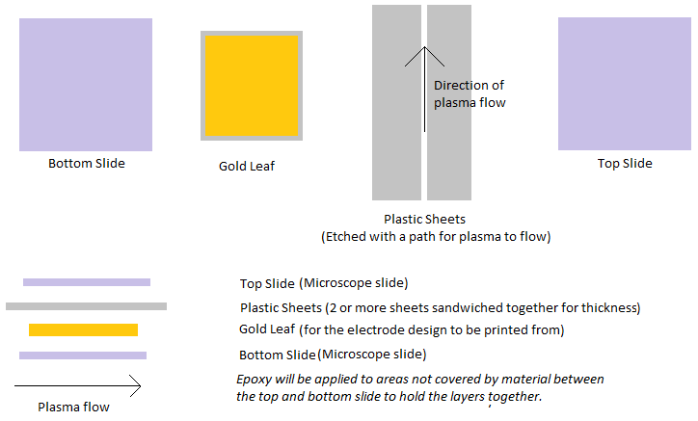*A shortlist of materials can be found in appendix but the design is not confirmed*

**Control device design**

The control device will have

* Potentiostat to power and read input from the E-AB sensor
* Pump to provide fluid flow
* Chasis
* Computational power and software to process sensor data and modulate output
* Actuator to control drug output (potentially as an add on to current hospital drip bags)
* Modular sensor design to enable swapping out of sensor component

*A shortlist of materials can be found in appendix*

**References**

1. [Aptamer immobilization protocol - http://www.nature.com/nprot/journal/v2/n11/full/nprot.2007.413.html](http://www.nature.com/nprot/journal/v2/n11/full/nprot.2007.413.html)
2. [Tobramycin aptamer sequence - http://www.mdpi.com/1424-8220/15/4/7754/htm](http://www.mdpi.com/1424-8220/15/4/7754/htm)
3. [Microfluidic electrochemical sensor design - http://microfluidics.utoronto.ca/papers/c4cs00369a.pdf](http://microfluidics.utoronto.ca/papers/c4cs00369a.pdf)
4. [Electrochemical Biosensor Principles and Architectures - https://www.ncbi.nlm.nih.gov/pmc/articles/PMC3663003/](https://www.ncbi.nlm.nih.gov/pmc/articles/PMC3663003/)
5. [Real Time Aptamer based biosensor design - https://www.ncbi.nlm.nih.gov/pmc/articles/PMC4010950/](https://www.ncbi.nlm.nih.gov/pmc/articles/PMC4010950/)
6. [Cheap Potentiostat design - https://www.ncbi.nlm.nih.gov/pmc/articles/PMC3172209/](https://www.ncbi.nlm.nih.gov/pmc/articles/PMC3172209/)
7. [Sputtering - http://www.sciencedirect.com/science/article/pii/S1388248116301102](http://www.sciencedirect.com/science/article/pii/S1388248116301102)
8. [Integrating electrodes into microfluidic chip - http://www.microfluidicsinfo.com/electrodesimt.pdf](http://www.microfluidicsinfo.com/electrodesimt.pdf)
9. [DIY Microfluidics - http://www.science-practice.com/blog/2015/01/29/low-tech-microfluidics/](http://www.science-practice.com/blog/2015/01/29/low-tech-microfluidics/)

**Appendix - Materials List**

Biosensor1

|  |  |  |  |
| --- | --- | --- | --- |
| Material | Quantity | Estimated Cost | Source |
| Tobramycin aptamer | ? | Quote needed | Biosearch Technologies |
| 3d printed microfluidic device | ? | Quote needed | Media Studio (Addenbrooke’s Hospital) |
| Phosphate Buffered Saline pH 7.2 | 1 | £11.68/500ml | Fischer Scientific |
| Sodium Hydroxide(10M) | 1 | £35.30/L | Fischer Scientific |
| Potassium Chloride / Sulfuric Acid | 1 | £19.02/L | Fischer Scientific |
| 1 um diamond suspension | 1 | ? | Buehler |
| 0.05um Gamma Alumina | 1 | ? | Buehler |
| Microcloth | 1 | ? | Buehler |
| Absolute Ethanol | 1 | £32.24/L | Fischer Scientific |
| 6-Mercaptohexanol | 1 | £53.80/5ml | Sigma Aldrich |
| 8 M guanidine-HCl | 1 | £106.50/100ml | Sigma Aldrich |
| Tris-2-carboxyehtyl phosphine hydrochloride | 1 | £68.50/10ml | Sigma Aldrich |

Equipment needed

* Sonicator
* Potentiostat - Alternating Current Voltammetry
* Reference Electrode (Ag/AgCl)
* Platinum Wire
* Dark room

**Potentiostat6**

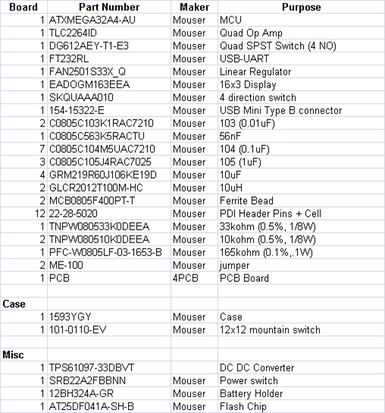

**Method**

*3rd phase*

* Software to be able to predict output based current plasma levels (comes with the hardware, still need to be programmed)

*4th phase*

* Test the system out with more complicated drugs and develop additional modules to handle it, such as for drugs with high Vd, Slow Distribution, Low blood/gas and High Tissue/Blood coefficients

Beaker of plasma, with sensor to detect levels and feedback to the effector to increase or decrease input of drug into the bloodstream.

Further checked with the use of plasma switching to mimic clearance in real humans.

Proof of concept

**Outcome and Benefit**

To be able to simplify the detection of the drug levels in plasma and to be able to generate a constant feedback loop allowing the drug levels to be tailored to the patient's clearance of the drug.

*1st phase*

* Low Vd(~3L), Low therapeutic dose (***aminoglycoside***, cardiac glycosides, Chemotherapeutics), Rapid redistribution, High Blood/Gas, Low Tissue/Blood coefficients
* What makes a good biosensor (sensitivity, etc.)
  + Transduction system to detect the drug in question

***Things to do (Saturday)***

MAIN - Choose an antibiotic and read up on it - see the different methods of sensing drug levels

What range do we need biosensor to be sensitive over - read on this

Antibiotics

Water soluble (very low Vd, just plasma [plasma proteins]) - Daptomycin

(Low Vd, including ECF) - Beta Lactam Anitbiotics and **Aminoglycosides(Gentamicin/tobramycin)**

(High Vd) -- synercid, macrolide, FQ

Lipid Soluble (extremely high Vd, sequestered in tissues) -- Azithromycin

Vd for drugs increased with sepsis and fever

Elimination

Aminoglycosides (gentamicin/tobramycin) - mainly by glomerular filtration

High levels in blood may exacerbate renal failure. Bactericidal effect is concentration dependant

Sensing

**Therapeutic Drug Monitoring**

Currently done by many different professionals, e.g. physicians, clinical pharmacologists, clinical pharmacists, nurses, medical laboratory scientists, etc

*2 methods*

*Priori* -- Based on subpopulations and desired clinical endpoint to predict dose regimen

*Posteriori* -- pre analytical, analytical and post-analytical phases to determine dose regimen by detecting ACTIVE and TOXIC forms of the drug.

***Sensors***

(are enzymes difficult to work with?)

+transcutaneously

+intravenously (most probably this for us, due to simplicity)

1. Electrochemical RNA aptamer based sensors - folding based electrochemical sensors, electrode bound RNA(DNA) based aptamer biorecognition element. When the 26 nucleotide RNA aptamer sequence undergoes large conformational changes, the sensor works better.

Very good method. Testing used cell samples to get results. But it should be able to be used to detect in blood plasma. RNA aptamers have a higher binding affinity, but may be degraded by nucleases in the blood plasma. DNA aptamers have a lower binding affinity, but may be sufficient. RNA sensors appear to degrade only after a few days. Can be solved with a microfluidic system that protects the RNA sensor from the nucleases.

Affinity range -- 200nM to 42 µM (tested with tobramycin)

1. Amperometric biosensors - enzyme specificity and transduction of biocatalytic reactions into current signals. This can be single use, intermitent use or continuous use.

* Oxidase enzyme (H202 to generate electrons)
* Dehydrogenase Enzyme ( NADH to generate electrons)

Performance depends on the enzyme imobilisation techiques. Problems of fluctuating based on other substances in bloodstream and oxygen levels can be avoided by transferring electrons directly from the redox centre to the electrode surface (instead of a diffusion mediator)

Used for Paracetamol and Chlorpromazine

**Range for sensitivity necessary**

Therapeutic range -- 2–6 μM (4–10 μg/ mL)

Tobramycin and kanamycin -- hyperbolic saturation curves (single site binding), Kd = 319 and 281 μM (These are lower when in solution phase) Kd = 12 nM to 13.2 μM

Gentamicin -- Biphasic curves with decreased biosensor current at low concentrations but increased current at higher concentrations

**Dosage predictions with software**

I have a feeling we might need a simple self learning neural network to be able to personalise it to each individual. But this doesn’t seem like a priority right now.

The main important links

<https://www.ncbi.nlm.nih.gov/pmc/articles/PMC3675903/>

<https://www.ncbi.nlm.nih.gov/pubmed/24377296>

<https://www.ncbi.nlm.nih.gov/pmc/articles/PMC3082472/>

<https://www.ncbi.nlm.nih.gov/pubmed/972270>

<http://www.sciencedirect.com/science/article/pii/S0731708598000569>

**Microfluidic Chip Design**

Standard Venipuncture needle is 21 gauge : 514 micron diameter : 2.075 * 10^5 micron^2 cross section area

Reynold’s Number = $\frac{uL}{v}$

u = velocity of fluid - si unit (m/s)

L = characteristic linear dimension - si unit (m)

v = kinematic viscosity - si unit (m^2/s)

Laminar flow defined as reynold number < 1000

[Whole blood kinematic viscosity](http://www.viscopedia.com/viscosity-tables/substances/whole-blood/) at 37 deg C ~ 2.65 mm^2/s = 2.65 * 10 ^ -6 m^2 / s

Linear dimension should be roughly the same as the 21 gauge meaning 514 micron diameter so around 5.14 * 10 -4 m

Reynold’s Number = $\frac{u × 5.14×{10}^{-4}}{2.65 × {10}^{-6}}=u×1.94 ×{10}^{2}$

So in order to maintain a reynolds number below 1000 we would need to have flow rates below 5 cm/s.

Assuming a **rectangular cross section area** for the microfluidic device, if we take the width of the channel to be **514 microns**, the height needs to be 403.70 microns or around **400 microns**. The thickness of a piece of paper or transparency is around **100 microns**, so we may need to stack 3 or 4 sheets accounting for glue adding thickness and thickness of the imprinted electrodes in the channel. Ideally we should have a micrometer screw gauge to measure this. To ensure the width of the channel is about 514 microns, we could devise a **wedge out of plastic sheets and glue to about 500 microns** and then when we etch make sure it fits inside the etching? I think we should enquire about the 3D printing process as well, once I get an AutoCAD design file done maybe we can get a quotation from addenbrookes and compare the price to doing it with the gilding.

Another issue to consider is the printing of the electrodes onto the chip. From what I read the counter electrode needs to be larger than the working by maybe around 10 times. A standard glass slide length is around 75mm so maximally if the working electrode has a length of 7.5mm then the working electrode needs to have a length of 75mm. However we need to leave some space for reference electrode as well, so maybe if we have a 5mm length working electrode and a 5cm length counter electrode, then around 2cm is leftover for the reference. We probably need to read up more on electrode design because the position and shape etc of electrodes can affect as well. **But I was thinking of printing the reference and counter electrodes on one glass slide (top) and working on the other (bottom)** so that when we have to apply the aptamer immobilisation protocol we can do it to working electrode without worrying about adding them to the counter and reference. However, if we use platinum leaf for the counter and reference maybe the reaction won’t affect them as well. Nevertheless I think if we separate the working and counter+reference electrode its better for the system also, like the current passing in the counter electrode might affect other electrodes not sure.